

2007

Mid Year Examination

HSC CHEMISTRY

Thursday 22 March, 9 – 11am
General Instructions  - Reading time - 5 minutes  - Working time - 2 hours  - Write using black or blue pen  - Draw diagrams using pencil  - Board approved calculators may be used  - A Data Sheet and Periodic Table are provided at the back of this paper  - Write your student number at the top of every page.  Mr Hunter  Miss Dreesbeimdieke  Mr Weeding  44 students | Total marks - 65  Section I – 45 marks  Part A (15 marks)  - Attempt Questions 1-15  Part B (30 marks)  - Attempt Questions 16- 22  Section II - 20 marks  - Attempt Question 23

Blank Page

Section 1
45 marks

Part A

Total marks 15
Attempt questions 1-15

Use the Multiple-choice Answer Sheet provided.

Answer the questions by selecting the alternative that best answers the question. Indicate your choice by filling in the appropriate place on the Answer sheet, as shown below, where A has been selected as the best alternative,
A
B
C
D

If you make a mistake, indicate your choice by labelling the correct alternative, as shown below where, the original choice A was a mistake, and C is now selected as being the correct answer.
Correct
A
B
C
D
X

- Consider the following reaction:

Zn _{(s)} + 2H⁺ _{(aq)} + 2MnO₂ _{(s)} → Zn²⁺ _{(aq)} + Mn₂O₃ _{(s)} + H₂O _{(l)}

What is the reductant in this reaction?

- MnO₂ _{(s)}
- Mn₂O₃ _{(s)}
- Zn _{(s)}
- H⁺ _{(aq)}

  - Identify the amphiprotic species.

- methanol
- water
- ammonium sulphate
- calcium carbonate

- The pH values of four acids and their concentrations are shown in the table below.

Acid | Concentration  (mol/L) | pH
A | 0.1 | 2.0
B | 0.1 | 1.0
C | 0.05 | 1.0
D | 0.01 | 2.0

Which acid is diprotic?

- A
- B
- C
- D

  - Which group of substances below would produce a solution with a pH greater than 7?

- ammonia, sodium hydroxide, potassium carbonate
- carbon dioxide, sulphur dioxide, hydrogen iodide
- hydrogen chloride, ethanol, carbon dioxide
- sodium oxide, nitrous oxide (N₂O), magnesium hydroxide

  - Two drops (0.1mL) of 0.1 mol/L HCl is added to a small beaker of each of the following solutions. In which beaker will the pH of the solution stay approximately constant?

- A solution of ethanol and ethanoic acid.
- A solution of ethanol and ethane.
- A solution of ethanoic acid and sodium ethanoate.
- An equimolar solution of ethanol and sodium ethanoate.

  - An unknown chemical was extracted from a soil sample and sent to a laboratory. The following result was achieved using indicators.

Indicator | Colour
Phenolphthalein | colourless
Methyl orange | red
Bromothymol blue | yellow

It can be assumed that the unknown chemical is:

- strongly acidic
- slightly acidic
- neutral
- slightly alkaline

  - Which curve below would represent the change in pH in a conical flask when a solution of sodium hydroxide (from a burette) is added to a solution of hydrochloric acid (in the conical flask)?

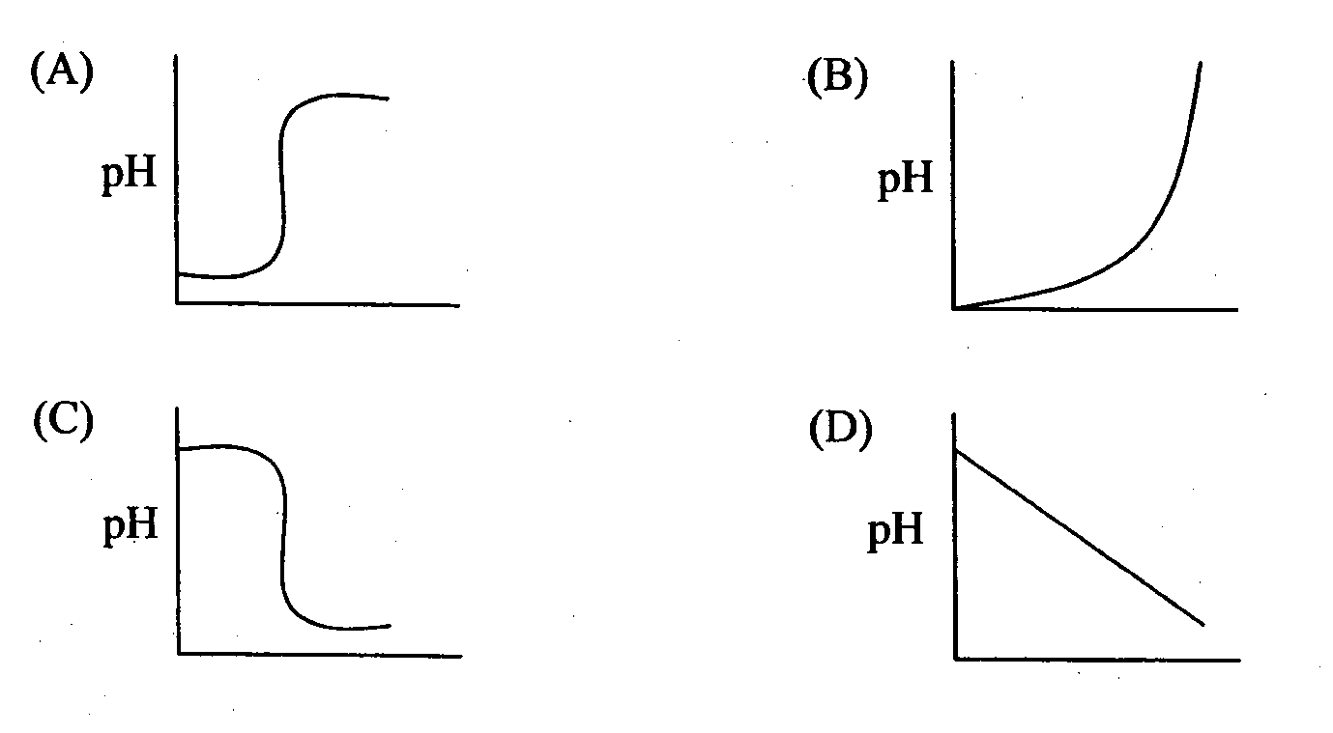

- Calculate the mass of carbon dioxide formed when 1.67g of ethanol reacts with excess oxygen gas to ensure complete combustion.

  - 0.80g
  - 1.59g
  - 3.19g
  - 44.0g

- Consider the following diagram.

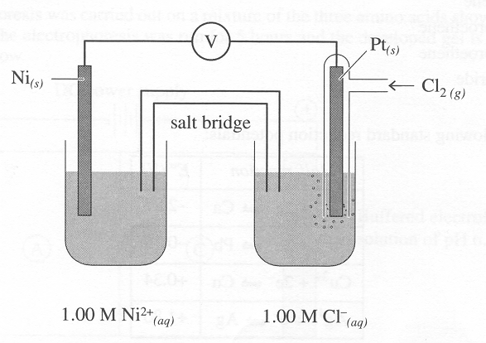

Which of the following describes what happens to the concentrations of nickel ions, chlorine gas and chloride ions and the masses of the nickel and platinum electrodes as this galvanic cell operates under standard conditions.

 | Concentration of Ni ²⁺ | Concentration of Cl₂ | Concentration of Cl ⁻ | Mass of Ni electrode | Mass of Pt electrode
(A) | decrease | no change | no change | increase | no change
(B) | increase | decrease | increase | decrease | no change
(C) | decrease | increase | increase | increase | decrease
(D) | increase | decrease | increase | decrease | increase

- Which of the following substances would NOT be present in the reaction flask during the preparation of propyl ethanoate

  - 1-propanol
  - ethanoic acid
  - propanoic acid
  - concentrated sulphuric acid

- A student performs a titration between acetic acid and sodium hydroxide. The acid is delivered from the burette and the sodium hydroxide is in the conical flask.

Which of the following shows the best rinsing procedure that the student should follow?

 | Pipette | Conical Flask | Burette
(A) | Rinsed with NaOH | Rinsed with distilled H₂O | Rinsed with CH₃COOH
(B) | Rinsed with distilled H₂O | Rinsed with NaOH | Rinsed with distilled H₂O
(C) | Rinsed with NaOH | Rinsed with distilled H₂O | Rinsed with distilled H₂O
(D) | Rinsed with distilled H₂O | Rinsed with NaOH | Rinsed with CH₃COOH

- A student added 20mL of 1 mol/L HCl (aq) to 20mL of 1 mol/L NaOH (aq) at room temperature. The column graph that correctly compares the temperature of the solutions before they were reacted and once the reaction is complete is -

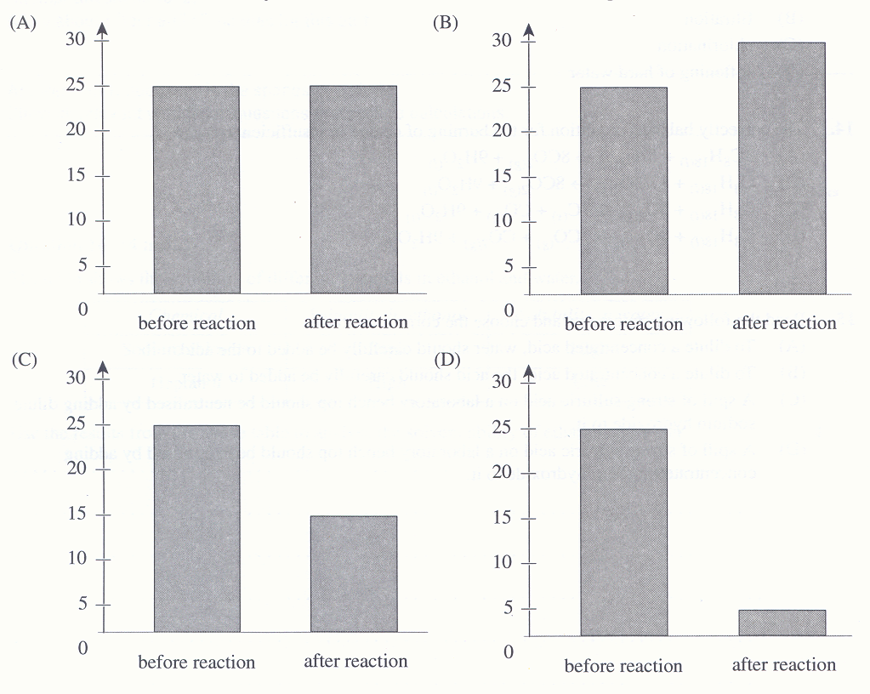

- Identify the entry in the table below that correctly identifies a Bronsted-Lowry acid base pair.

 | Acid | Base
(A) | H₂F₂ | HF
(B) | H₂O | OH⁻
(C) | HCO₃⁻ | H₂CO₃
(D) | CH₃COOH | CH₃OH

- Heart pacemakers are often powered by lithium-silver chromate button cells. The overall reaction is:

2 Li _{(s)} + Ag₂Cr₂O₄ _{(s)} ↔ Li₂Cr₂O₄ _{(s)} + 2Ag _{(s)}

What is the anode this cell?

  - Ag
  - Li
  - Ag⁺
  - Cr₂O₄²⁻

    - During a first-hand investigation, a student recorded the following results:

Metal E displaces ions of metal F. Metal F displaces ions of both metals G and H. Both metals G and H displace ions of metal I.

Based on these results, which scenario below is correct if a galvanic cell was to be established?

 | Anode | Cathode | Electron movement
(A) | G | H | H → G
(B) | F | G | F → G
(C) | E | I | I → E
(D) | E | G | G → E

Section 1 (continued)

Part B – 30 marks
Attempt Questions 16-22

Answer the questions in the spaces provided.

Show all relevant working in questions involving calculations.

Question 16 (5 marks)  You have performed a first-hand investigation in which you identified the pH of a range of salt solutions.  (a) Outline the procedure you used for your first-hand investigation.  ………………………………………………………………………………………………………………….  ………………………………………………………………………………………………………………….  ………………………………………………………………………………………………………………….  ………………………………………………………………………………………………………………….  ………………………………………………………………………………………………………………….  ………………………………………………………………………………………………………………….  (b) Predict the acidic, basic or neutral nature of ammonium nitrate and sodium ethanoate. Justify your  prediction, including relevant equations in your answer.  ………………………………………………………………………………………………………………….  ………………………………………………………………………………………………………………….  ………………………………………………………………………………………………………………….  ………………………………………………………………………………………………………………….  ………………………………………………………………………………………………………………….  ………………………………………………………………………………………………………………….  …………………………………………………………………………………………………………………. | Marks  3  2

Question 17 (4 marks)  Although the atmosphere naturally contains acidic oxides of nitrogen and sulphur, the levels of these oxides have been increasing since the industrial revolution.  Assess the evidence which indicates increases in atmospheric concentration of these oxides.  ………………………………………………………………………………………………………………….  ………………………………………………………………………………………………………………….  ………………………………………………………………………………………………………………….  ………………………………………………………………………………………………………………….  ………………………………………………………………………………………………………………….  ………………………………………………………………………………………………………………….  ………………………………………………………………………………………………………………….  ………………………………………………………………………………………………………………….  ………………………………………………………………………………………………………………….  ………………………………………………………………………………………………………………….  ………………………………………………………………………………………………………………….  ………………………………………………………………………………………………………………….  ………………………………………………………………………………………………………………….  ………………………………………………………………………………………………………………….  ………………………………………………………………………………………………………………….  ………………………………………………………………………………………………………………….  ………………………………………………………………………………………………………………….  ………………………………………………………………………………………………………………….  …………………………………………………………………………………………………………………. | Marks  4
Question 18 (5 marks)  (a) In the space below, sketch a graph that demonstrates the difference in boiling points between  alkanes, alkanoic acids and alkanols.  (b) Explain the trends in boiling points shown in the graph.  ………………………………………………………………………………………………………………….  ………………………………………………………………………………………………………………….  ………………………………………………………………………………………………………………….  ………………………………………………………………………………………………………………….  ………………………………………………………………………………………………………………….  ………………………………………………………………………………………………………………….  ………………………………………………………………………………………………………………….  ………………………………………………………………………………………………………………….  ………………………………………………………………………………………………………………….  ………………………………………………………………………………………………………………….  ………………………………………………………………………………………………………………….  …………………………………………………………………………………………………………………. | Marks  2  3

Question 19 (5 marks)  (a) Many commercial products contain acids and esters. Using specific examples, outline the use of  esters and acids found in products that can be purchased in the supermarket.  ………………………………………………………………………………………………………………….  ………………………………………………………………………………………………………………….  ………………………………………………………………………………………………………………….  ………………………………………………………………………………………………………………….  ………………………………………………………………………………………………………………….  ………………………………………………………………………………………………………………….  (b) Draw a diagram of the reflux apparatus used in the preparation of an ester in the laboratory. | Marks  2  3

Question 20 (3 marks)  Wayne is a very poor surfer so he would rather collect shells at the beach and determine the percentage composition of calcium carbonate in the shells he finds.  He placed a clean dry shell which weighed 1.306g in a small beaker. To this he added 10mL of 5 mol/L hydrochloric acid to dissolve the shell completely. The HCl is in excess. The resulting solution was transferred into a volumetric flask and the volume was made up to 25mL with distilled water. A 10mL sample from this solution required 11.2mL of 1 mol/L NaOH for complete neutralisation.  Calculate the percentage of calcium carbonate in the shell.  ………………………………………………………………………………………………………………….  ………………………………………………………………………………………………………………….  ………………………………………………………………………………………………………………….  ………………………………………………………………………………………………………………….  ………………………………………………………………………………………………………………….  ………………………………………………………………………………………………………………….  ………………………………………………………………………………………………………………….  ………………………………………………………………………………………………………………….  …………………………………………………………………………………………………………………. | Marks  3
Question 21 (5 marks)  In order to produce a cell with a voltage between 1.1V and 1.2V, a student constructed a Galvanic Cell with copper and silver half cells using a potassium chloride salt bridge. The cell was set up under standard conditions.  (a) Draw a diagram of the Galvanic Cell the student constructed.  (b) Assess this students’ experimental design.  ………………………………………………………………………………………………………………….  ………………………………………………………………………………………………………………….  ………………………………………………………………………………………………………………….  ………………………………………………………………………………………………………………….  ………………………………………………………………………………………………………………….  ………………………………………………………………………………………………………………….  ………………………………………………………………………………………………………………….  ………………………………………………………………………………………………………………….  …………………………………………………………………………………………………………………. | Marks  2  3

Question 22 (3 marks)  The diagram below can be used to compare the relative strengths of three different acids.  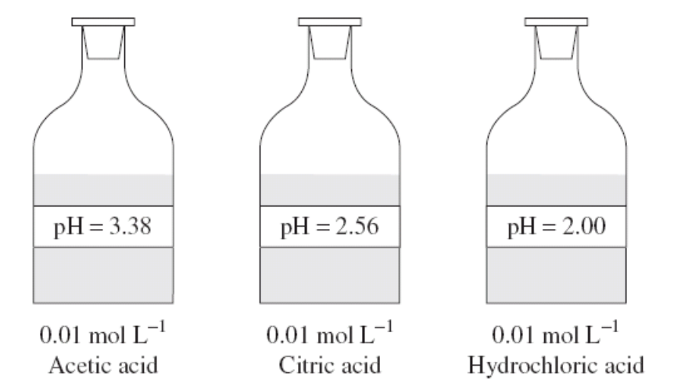  Use the information provided in the above diagram to describe the difference between a strong and a weak acid in terms of an equilibrium between the intact molecule and its ions.  ………………………………………………………………………………………………………………….  ………………………………………………………………………………………………………………….  ………………………………………………………………………………………………………………….  ………………………………………………………………………………………………………………….  ………………………………………………………………………………………………………………….  ………………………………………………………………………………………………………………….  ………………………………………………………………………………………………………………….  ………………………………………………………………………………………………………………….  …………………………………………………………………………………………………………………. | Marks  3
Section II
20 marks
Answer Question 23 below.
Answer the question in a writing booklet. Extra writing booklets are available. Show all relevant working in questions involving calculations.
Question 23 – Shipwrecks, Corrosion and Conservation (20 marks)  (a) A student was asked to compare and explain the solubility and concentration of selected gases at  increasing depths in the oceans.  The student found the following information on the internet.  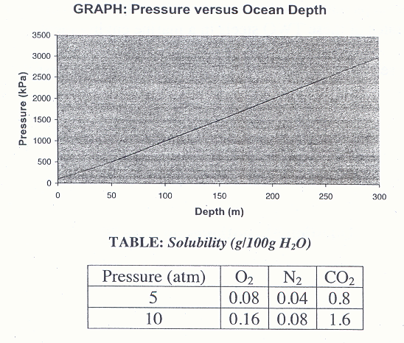  Evaluate the relevance of this information in relation to the area of investigation.  (b) Sea water contains a variety of ions including sodium, magnesium, calcium, potassium, chloride,  sulphate and hydrogen carbonate.  Explain the origins of these ions from minerals in the oceans.  (c) In your practical work, you performed a first-hand investigation to identify factors that affect the  rate of an electrolysis reaction.  (i) Outline the method you used to show how ONE factor effects the rate of an electrolysis  reaction, making sure that you incorporate a risk assessment.  (ii) Provide a conclusion based on the results you achieved in this experiment.  (d) (i) Explain what steel is.  (ii) Compare the composition, properties and uses of TWO types of steel.  END OF EXAM | Marks  5  Marks  4  4  2  1  4

BLANK PAGE
